IN3005: Computer Graphics using OpenGL

By Tadas Vaisvila

**Project Overview:**

The projects original concept was a chase scene where a drunk driver tries to flee police whilst driving along weirdly shaped paths. The goal is to avoid any obstacles by moving left or right along the road.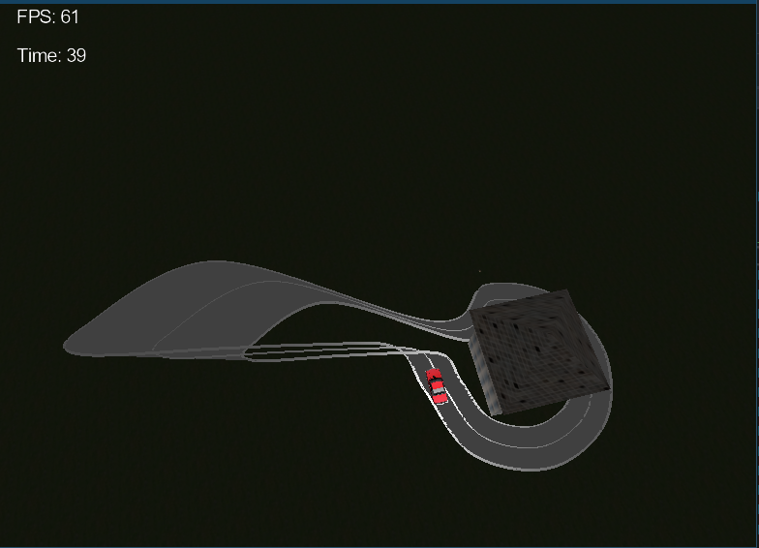

**(Note that the road goes up in Y direction so that is why part of it looks untextured)**

The car on the road represents the playable character and the spotlight imitates a helicopter.

The Controls are as follows:

|  |  |
| --- | --- |
| E | Look Right |
| Q | Look Left |
| V | 3rd Person View |
| X | Camera Shake (For Testing) |
| O | Speed Increase |
| P | Speed Decrease |

**Requirements Met:**

Route was created by referring to a given guide by using a centerline and its offsets which were interpolated to connect the control point points with a line. Later, those points were used to create triangles along the path so the road could be textured. The road shape was changed by adding new control points to the code. (Seen in the picture above)

New Camera angles were implemented by building on top of the camera that was implemented using the given guide. Left and Right views were achieved by using glm::rotate() function and 3rd person view was done by increasing y value of the camera.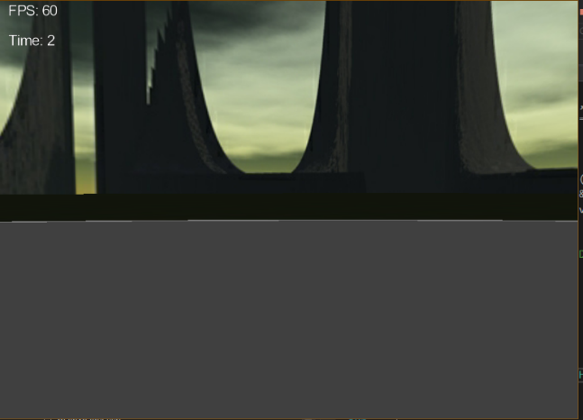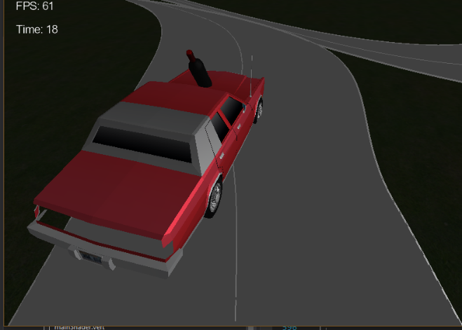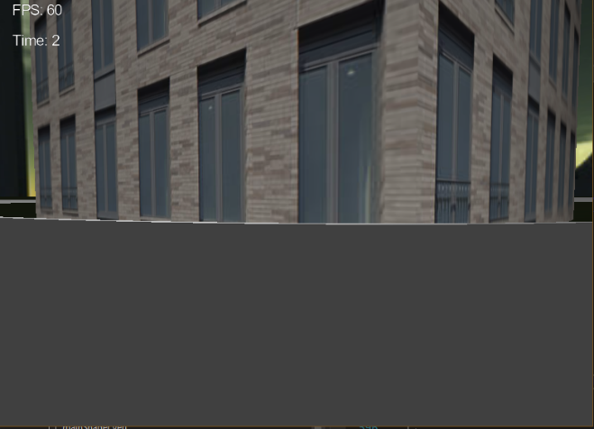

Two new basic objects were created. One of them is a pyramid that was used as a roof and the other one is a cube that was used as a building. The pyramid was done in a similar fashion to the route as I have used GL_TRIANGLE_STRIP to render it. That means that I had to match 2 of the last created vertices with the newly created triangle to get the shape right. Afterwards, I had to set correct texture coordinates and normals. I did so by using plane shape as a reference. The cube was created by using GL_TRIANGLES as I have wanted to try a different approach. Thus, the required number of vertices was increased almost 3 times as I was creating a new triangle from 3 new vertices. While it gave me freedom of placing triangles wherever I wanted to, texturing was a lot more difficult than it was with the pyramid, since the code for texturing I used was created for GL_TRIANGLE_STRIP.

Both objects were transformed to create a house in the middle of the map. 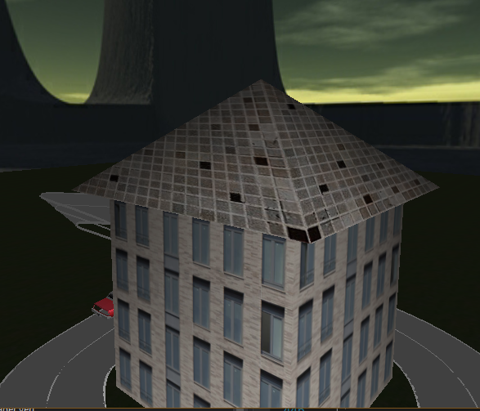

The two meshes I have imported were a car and a bottle. They were loaded using ShaderProgram Load() function and were transformed to be on top of the road, bottle being on top of the car. Barrels were reused to create an obstacle of stacked meshes on the road.

(Can be seen in the 2nd picture under camera implementation)

A dynamic light was added by applying tick rate counter and a sine wave which were applied to a light position to create a circular motion to imitate a helicopter spotlight.

(Can be seen in the 1st picture)

For HUD I have implemented a timer that shows the time that has passed in seconds. It was achieved by counting milliseconds and converting them into seconds by using a int variable in a m_time_elapsed loop. It was drawn on the screen using fontProgram shader.

(Can be seen in the 1st four pictures)

None of the gameplay aspects work as intended, the only attempt at it was trying to change speed with O and P inputs, but they do not affect the gameplay.

For Advanced rendering I chose Camera shake and I have implemented it by adding a rapid sine wave to the camera view, creating a shaking effect.

**Scene Assets:**

Bottle Mesh and Texture Downloaded from https://free3d.com/3d-model/-ml-wine-bottle-v1--691507.html on 25 Apr 2019 Under Personal Use License.

Car Mesh and Texture Downloaded from [https://www.turbosquid.com/3d-models/cartoon-chrysler-car-3d-model-1496394 on 25 Apr 2019](https://www.turbosquid.com/3d-models/cartoon-chrysler-car-3d-model-1496394%20on%2025%20Apr%202019) Under TurboSquid License: <https://blog.turbosquid.com/turbosquid-3d-model-license/>

House texture https://www.textures.com/system/gallery/photos/Buildings/High%20Rise/Office/66496/BuildingsHighRise0497_1_600.jpg?v=4 on August 24 2020 Under Personal Use License

Blender was used to set correct normals in some cases.

**Discussion:**

I think my submission is average at best, but I believe I did a decent job with primitives and camera positions. I did struggle with texturing a GL_TRIANGLES rendered cube, but I managed to do it properly after some time. My lighting and rendering techniques still need a lot of work as I have done a pretty barebones implementation of them both. I was not able to implement any of the gameplay features within given time as I had to do a lot of resits during the same period due to COVID-19 situation. The features that are lacking from the full game experience would be: controllable driving along the path, more complex track, collectables such as speed boosts, other race cars, implementation of a health bar which decreases if the player hits an obstacle, different tracks.